Building At Chembur.

1. Project Information
- Project Name: Gami Jaydeep Estella
- Location: __________________
- Plot Area: __________________
- Built-up Area: __________________
- Project Type: High-rise residential and commercial development
- Client/Developer: Gami Group & Jaydeep Group
- Status: __________________
- Completion Year: __________________

2. Project Overview
Gami Jaydeep Estella is a contemporary residential tower with an active commercial frontage and extensive rooftop amenities. The project combines modern façade detailing, landscaped balconies and premium common areas. Its integrated recreational spaces create a complete urban lifestyle environment.

3. Building Features
- High-rise residential tower
- Ground-floor commercial spaces
- Grand entrance gateway
- Premium entrance and lift lobby
- Glass balconies with warm wooden soffits
- Vertical fins and decorative façade screens
- Landscaped balconies and terrace gardens
- Rooftop jogging track
- Multi-purpose sports court
- Children’s play area
- Pergola seating and social zones
- Landscaped lawns and outdoor lounges
- Integrated façade and landscape lighting

4. Overall Design Concept
The design combines clean vertical lines with curved balconies, warm materials and integrated greenery. A neutral white and grey palette creates a refined urban character, while rooftop recreation and landscaped community spaces enhance the residents’ lifestyle experience.

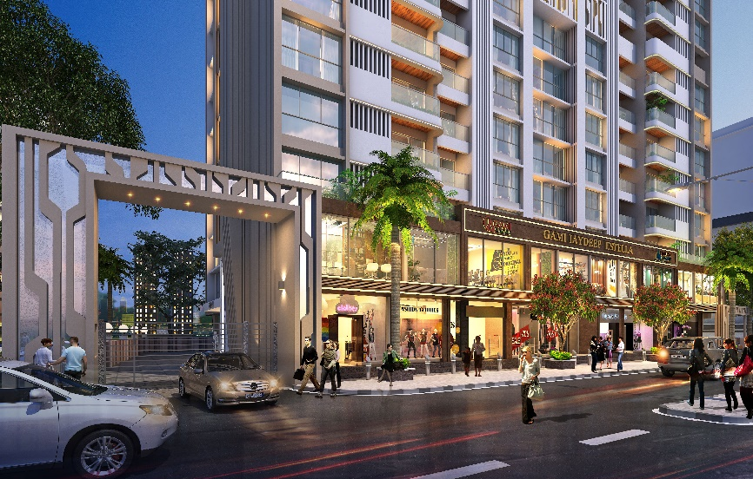
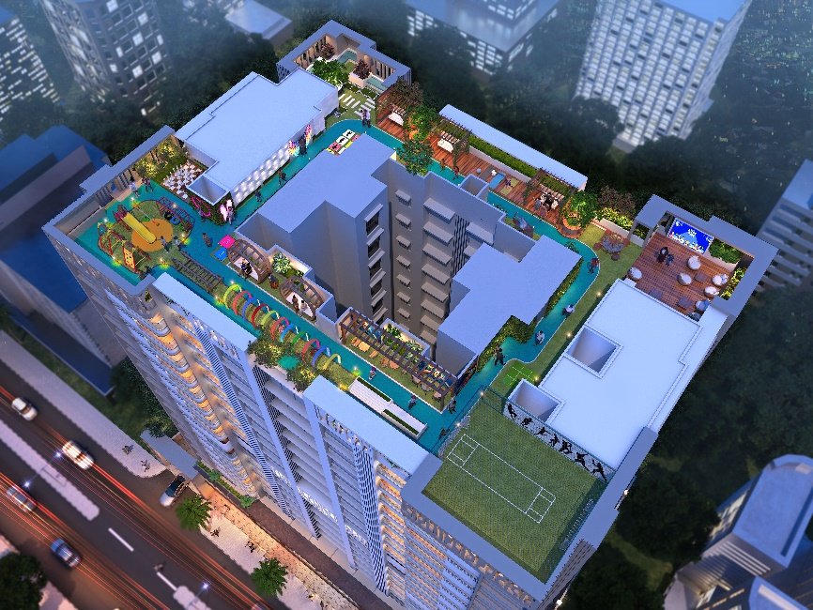
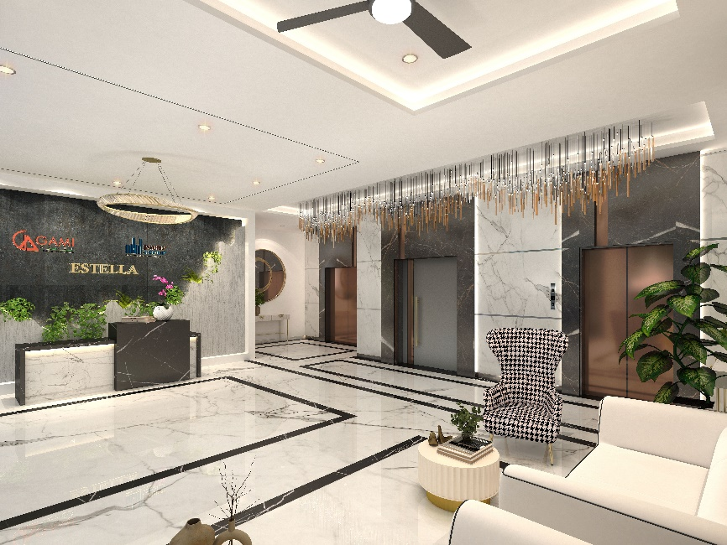
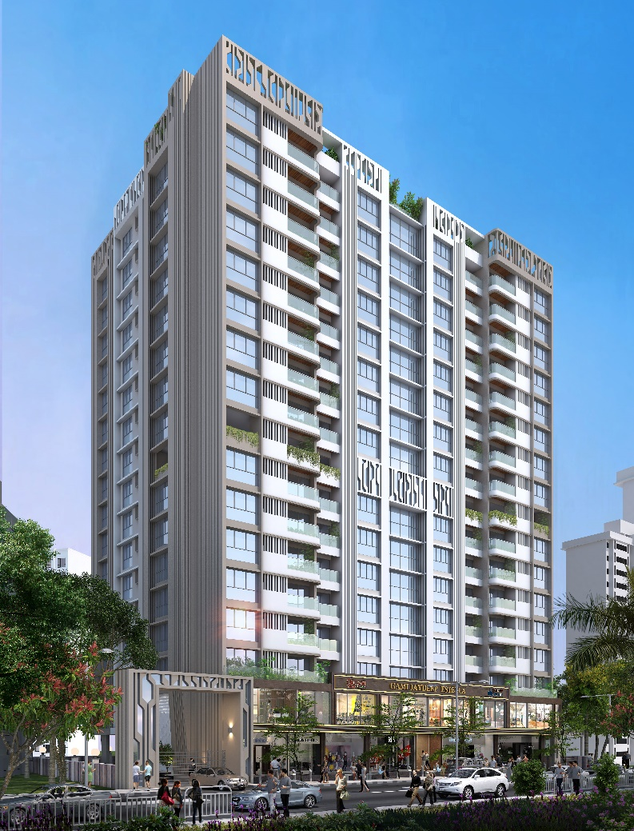
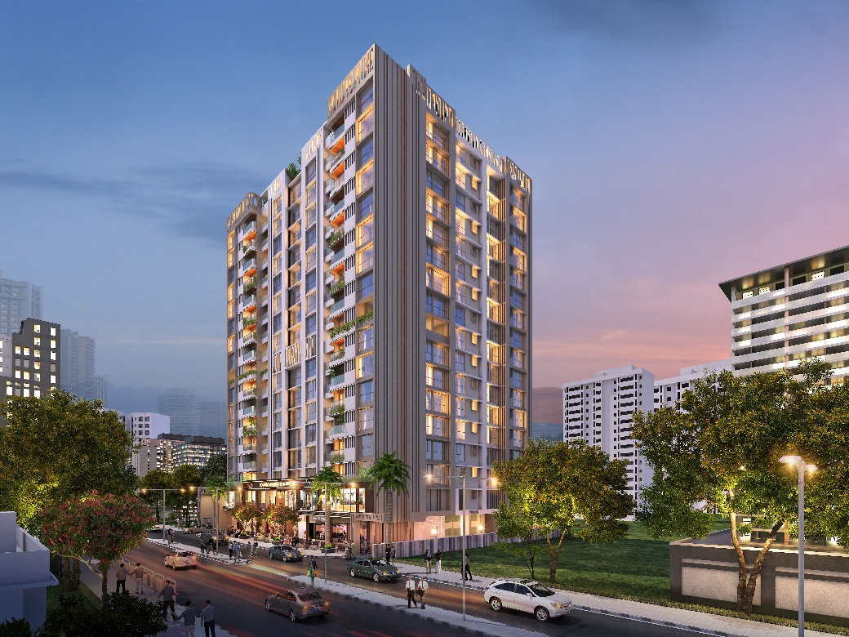
Image 3
Image 2
Image 1
Image 4
Image 5

